Proforma, pay attention to and change highlighted areas in particular.

Name of Club
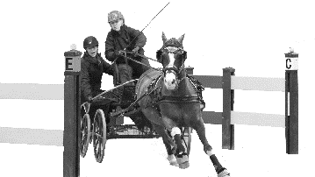
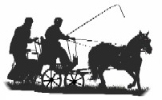
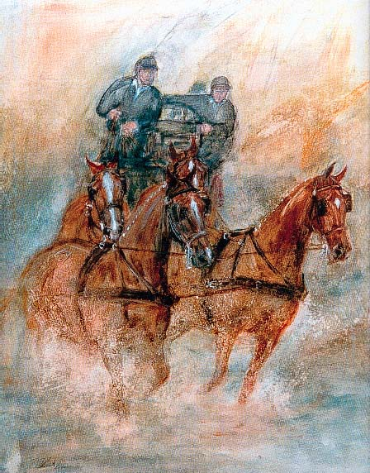
Indoor/Outdoor Carriage
Driving Competition
Precision, Speed, Excitement.

Date 2024
Location
This Event will be driven on an Indoor or Outdoor arena

EVENT OFFICIALS
Event Supervisor - Add
Event Secretary - Add
Precision and Paces Judges - Add
Scorer - Add
Cones & Obstacle Judge - Add

Judges decisions are final
PROGRAMME
EVENT 1
Indoor/Outdoor Carriage Driving - 3 phases

A- Precision & Paces
Arena 50m x 20m

Indoor Carriage Driving UK Test 2022-2023 Season Version 3 - all classes

B- Cones
Driven at 220 metres per minute, approximately fast trot.
No stopwatches allowed.

C- Obstacles
EVENT 2
Speed Cones - One round-fastest, clear round to win.
SCHEDULE
Event 1 Indoor/Outdoor Carriage Driving

- Very Small Equines (under 91cm)
- Single Pony 91cm ne 124cm
- Single Pony 124cm ne149cm
- Single Horse Over 149cms
- Multiples, any Height
- First Season Driver
- Non-Competitive Junior participation class (optional class)
- Junior (optional Class)
- Club (optional Class)

Event 2 Speed Cones – driven immediately after Event 1 cones round

9. Single any height.
10. Multiple any height

Tea, Coffee and Sausage Sizzle available.
Indoor or Outdoor arena. sand, or grass or etc, ideal for driving.
Overnight camping allowed, showers, toilets.

APPROXIMATE TIMETABLE
9am Precision and Paces.
Cones
Speed Cones
Obstacles;
Competitors may be organised in groups
1st round followed by 2nd round obstacles.
or
All Competitors drive 1st round, Obstacles re-lettered 2nd round, Drivers have 10 minutes to learn new course.
Times will be emailed prior to the event.

QUALIFICATIONS FOR FINAL

Refer to the current version of the Rules and Guidelines
Enquiries:
Add information
Entry fee $40
(inc. speed cones)
Camping Fee $XXX per head per night
Yards $XXX (limited number – first in first served)
Horse on Grounds Fee $XXX per night/weekend

ENTRIES CLOSE Add information
ENTRIES
Online entry form link or contact xxx for alternative entry
or
ENTRIES TO
Add information
Direct Debit to:
Name of bank
BSB Add information
Account No: Add information
or if
Cheques/Money Orders made payable to the Add information
Email entry form to Add information
Entries will not be accepted without payment.

CONDITIONS OF ENTRY
The Event will be judged under the 2024 Australian Indoor/Outdoor Horse Driving Rules and any additional conditions included in this schedule.
- Drivers must be full members of the ACDS and horses must be minimum 4 years of age and ACDS registered.
- All competitors compete at their own risk.
- Junior drivers age, 6 -10 must be accompanied in the vehicle by an ACDS adult member (an experienced driving person) seated next to the driver at all times and holding a second pair of reins attached to the bit. Junior Drivers 11-15 must be accompanied in the vehicle by an ACDS adult member (an experienced driving person).
- Livestock control: Entrants /Owners of livestock are advised that horses must be adequately and securely restrained and controlled at all times.
- Dress code: Marathon gear, gloves and whip. Protective headgear is compulsory in accordance with ACDS rules.
- Properly completed medical information bands to be worn by Drivers & Grooms.
- Parents are responsible for the supervision of children at all times at this venue
- Class 7 will not be timed, and no scores will be tallied or published. All entries in this class will receive a participation ribbon
- Only the horses/ponies listed on the official entry are able to attend this event. Permission to bring additional horses/ponies must be sought and granted by the Organizing Committee prior to the event.
- Dogs
- Yards
- Special requests

Name of club
Indoor/Outdoor Driving Event
Date 2024
Location

ENTRY FORM

Name: ________________________________________________________________________________________________

Phone: __________________________________________ Mobile: _____________________________________________

Email: ________________________________________________________________________________________________

ACDS Affiliated Club: ____________________________________________________ ACDS Member No: ________________

Junior Driver: YES / NO (Please Circle) If yes, date of birth: ___ / ___ / ____

If Junior Driver, name of groom (experienced driving person who is an ACDS member

_____________________________________________________ ACDS member no______________

Entry Fees: One Day $Add Two days $Add

Class | Horse/Pony Name | ACDS Reg No. | Horse/Pony Height |  | Saturday | Sunday | Fee
Number of people camping _________ @ $Add per person
Horse on Grounds Fee@$Add per day/weekend
Yard fee @$Add
Have you sent payment via direct deposit?  (Please circle) Yes No |  | TOTAL AMOUNT |  |  |  |  | $

Note; Please check with the organising committee if you wish to drive twice or are sharing a carriage or have any other special requests prior to entering.

All competitors and their navigators/grooms compete at their own risk. Neither the ACDS, nor their appointed officials accept any liability for any accident, theft, illness or damage to horses, grooms or any person or property whatsoever. All competitors, by entering this event, agree to be bound by this regulation. I am aware of and agree to pay the excess that applies to any insurance claim which may arise from my participation in this event.

Competitor Signature: ______________________________________________ Date: ____________________________

Parent/Guardian Signature (if under 18 years old) ___________________________________________________________

Please complete and return form by add date to:
Add information | All cheques should be made payable to  Name of club  Direct Deposit to name of bank  Name: name of account  BSB: add Account No add

